**PDF Splitter User Guide**

1. Extract/Unzip the files to any location you prefer (Script might not work if the files aren’t extracted or unzipped)
2. After extracting, you should see the following files in the folder (Sample files are provided. They may be deleted if no longer needed.):   
   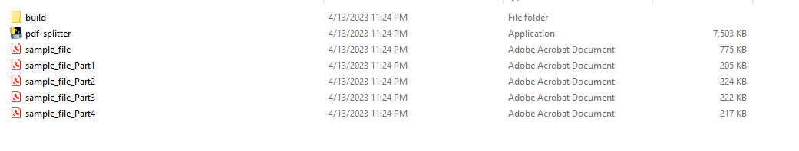
3. To use the splitter, the PDF you want to split should always be within the same folder as the script.
4. Copy the file name of the PDF you want to split. (Do not include .pdf extension).
5. Run the script “pdf-splitter”.
6. If you see the prompt below, just click “More info”, then “Run anyway”.  
   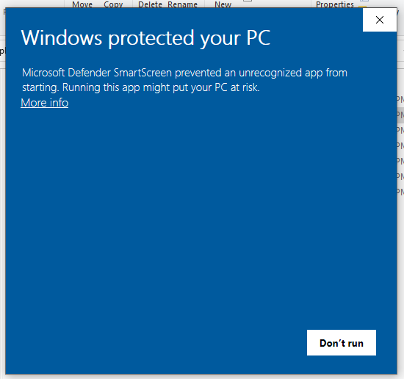
7. Wait for the terminal to open and prompt for the file name:  
   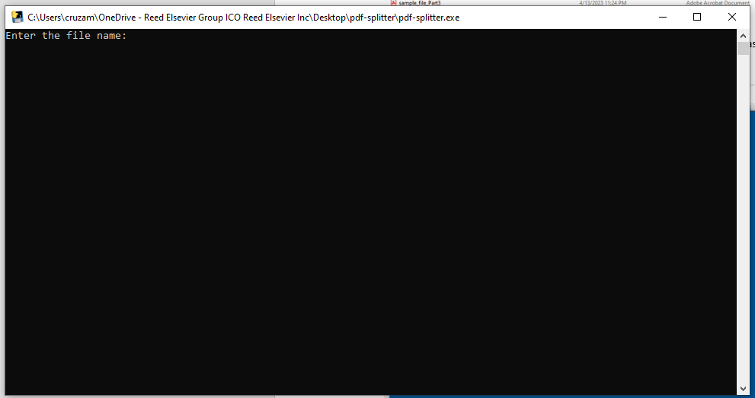
8. Paste the copied file name and press the **Enter** key. Then type in the number of how many parts you want the PDF to be split into. Press **Enter** key again.
9. It should return the output in the same folder.

For any issues with this script, please contact me: Aldrin Renz Cruz (aldrinrenzcruz@proton.me).